**PROJECT DEVELOPMENT PHASE**

**DELIVERY OF SPRINT -2**

|  |  |
| --- | --- |
| Date | 07 November 2022 |
| Team ID | PNT2022TMID51074 |
| Project Name | AI Based Discourse for Banking Industry |
| Maximum Marks | 8 Marks |

**Account Creation**

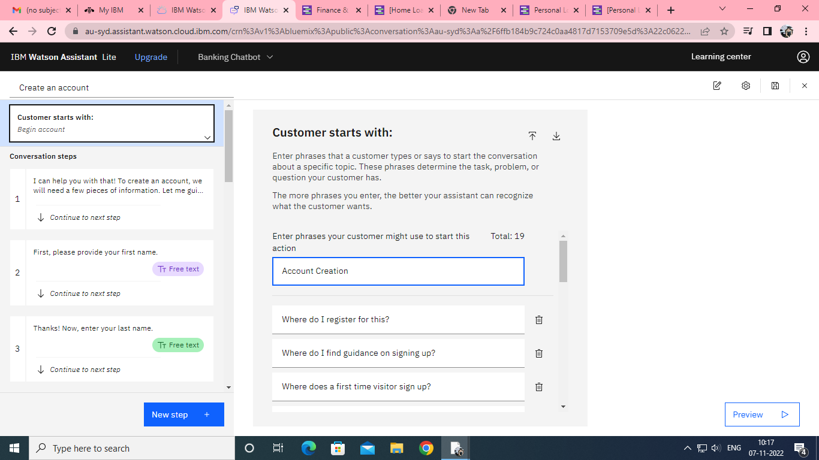

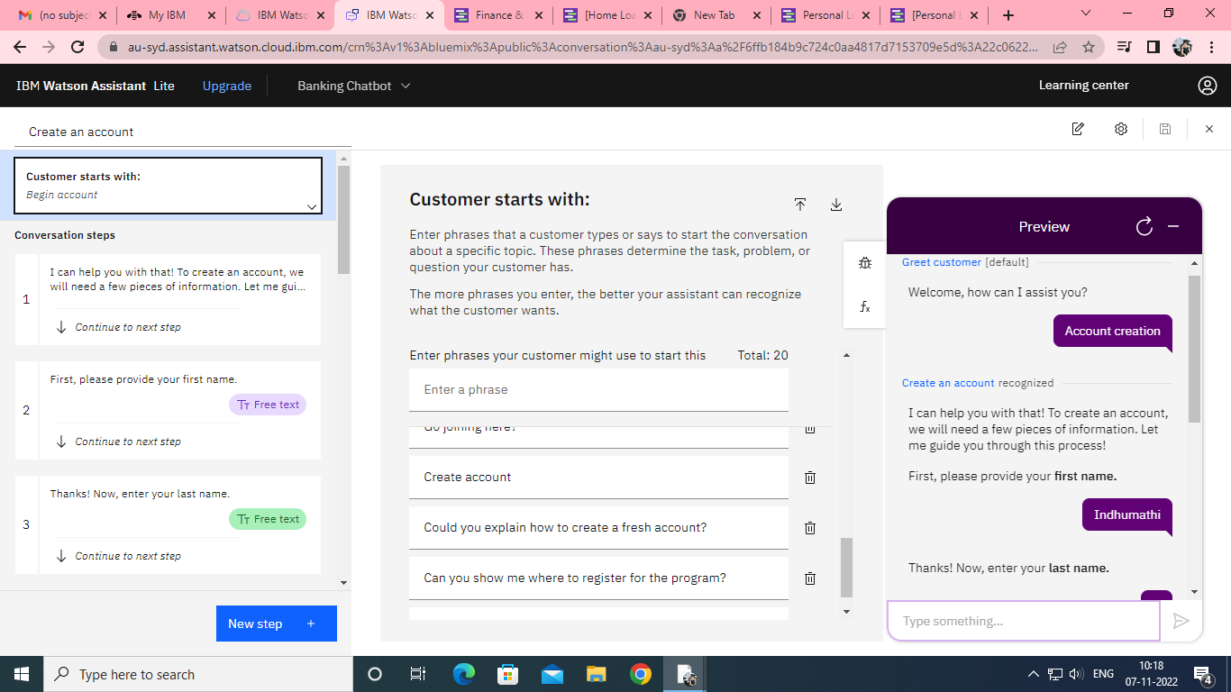

**Creation of Net Banking**

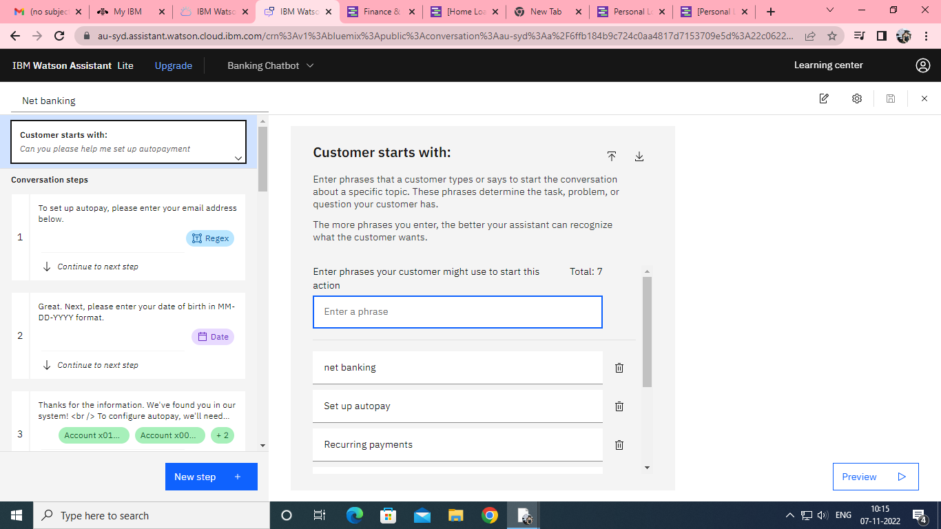

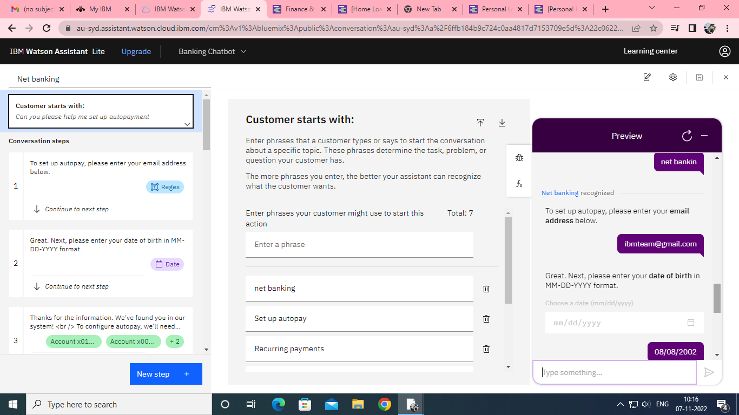

**Creation of Loan Queries**

